Participant information:

School Swimming Award 1

Time available: 30 min Age range: KS2 (Yr4) Number of Swimmers: 12
Equipment required:
Floating toys
Noodles
Floats
Armbands
Health & Safety checks (tick when satisfactory)
Poolside clean and dry |  | Water temperature |  |  | Lighting in good working order
Lifeguards present  (N/A if not required) |  | Water Clarity |  |  | Jewellery removed  (Teacher and swimmer)
Emergency equipment in place |  | Appropriate depth for session activities |  |  | Hair tied back  (Teacher and swimmer)
Session aim  (Which aquatic skills will be the focus)  Water Confidence :- Aquatic Breathing, Travel & Coordination |  |  | Specific objective  (By the end of the session swimmers will be able to...)  Be confident with water on their face  Blow into the water  Move around the pool
Water depth required for activities (circle)

Shallow depth up to 0.9 m Middle Depth Deep depth

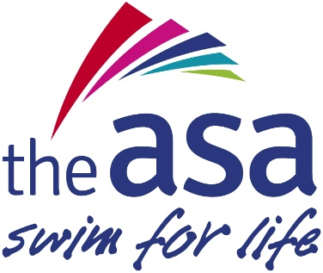
School:
Teacher:
Date of Lesson:
Time for each practice | Skill practice (what they do) | Skill teaching point  (what they think about)
Entry – one pupil at a time  2 minutes | Ladders | Look down to see where you are putting your feet  Basic rules for the session
Warm up – all pupils together in a circle  5 minutes | Washing machine game:  Lips in to blow bubbles(soap bubbles)  Lay on back and kick feet to make splash  Link hands and move Tin a circle to spin the clothes and then the opposite way. | Take off their pretend tops, trousers and stinky socks, pretend to add washing powder.  Blow into the water to make bubbles  Make big splashes to make clothes clean, the faster you move the quicker we spin our clothes
Skill development practices – all pupils together  3 minutes  3 minutes  3 minutes  3 minutes  3 minutes | Balance and Buoyancy  Washing body game  (use woggle to support if needed)  Wash your face  Wash your hair  Under your arms  Wash your feet  Float on the back  Aquatic breathing  1 x width pushing ball using hands  1 x width pushing ball with chin  1 x width pushing ball with nose  Travel and coordination  Shopping game  Each swimmer has a float (trolley) and with lots of floating toys on water they must collect as many as they can and bring them to the side | Cup the water in your hands and splash your face  Put lots of water on your hair and rub  Splash lots of water to wash with  Clean those toes  Lay on your back and show me your clean toes  One hand and then the other  Keep your hands behind your back  Only touch the ball with your nose  Collect as many toys as possible without dropping them
Cool down – all together  4 minutes | Sit on noodle for noodle race | Sit up straight and use your legs to push  Both at the same time
Safe exit - one pupil at a time  Evaluation – all class together  4 minutes | Exit by ladders  Focus on positive aspects – give hints and pointers for next lesson | Both hands on rail  Look in front

