ASA Level 1 Swimming Assistant
(Teaching) Residential
Application Pack

This application pack contains
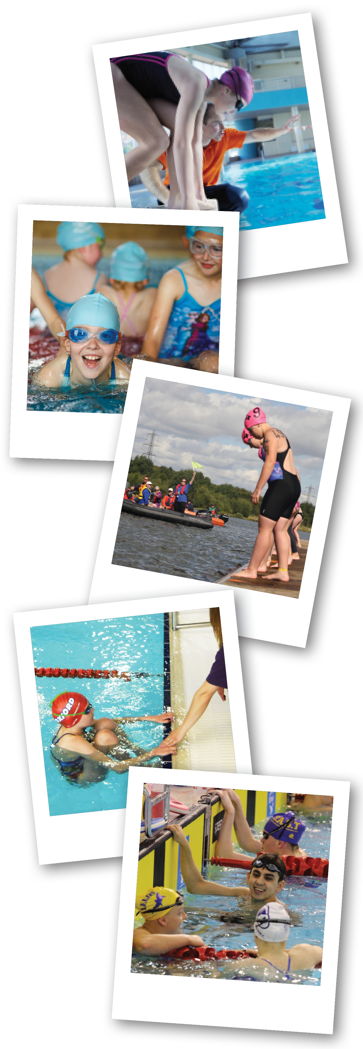

- Key Information about the event
- An application form for you to complete
- A parent/carer permission form
- FAQs

Key Information

What is it?

National Deaf Children’s Society is holding a residential course for 16 deaf young people aged 16 - 25 to achieve an ASA Level 1 Swimming Assistant (Teaching) qualification. You will spend four days learning swimming theory and technique, as well as getting hands on experience of teaching swimming with a fully qualified and deaf-aware swimming tutor. Communication support will be provided.

Once you are qualified, NDCS will continue to support you to take on:
- Volunteering
- Employment
- Further training opportunities

If there are more deaf swimming teachers and coaches, we
believe more deaf children and young people will be inspired to take up swimming and other aquatic sports. We want to enable you to work with other deaf young people in a swimming environment to make this a reality. This is a great opportunity to develop new skills and meet other deaf swimming teachers.

Arrival | Mon 30th May 2016  (bank holiday) approx 5-6pm
Course day 1 | Tuesday 31st May 2016
Course day 2 | Wednesday 1st June 2016
Course day 3 | Thursday 2nd June 2016
Course day 4  and departure | Friday 3rd June 2016 approx 5-6pm
When is it?
You must be able to attend all four days of the course.

Where is it?

Course venue:
Chase Leisure Centre, Stafford Road, Cannock, WS11 4AL
www.wlct.org/cannock/leisure-centres/chase/

Overnight accommodation:
Laches Wood, Outdoor Centre, Slade Heath, Wolverhampton, WV10 7PA
www.entrustoutdoors.co.uk/
Travel between the course venue and accommodation throughout the course will be arranged by NDCS.

What does it cost?

The cost of this event is approximately £650.00 per person. NDCS is subsidising a large portion of this cost and asking for a contribution of £150.00 per person.

Your contribution of £150.00 will go towards:
- Overnight accommodation
- Morning and evening meals
- Transport throughout the week
- Course and exam fees (RRP £395)
- Tutor costs and expenses
- Pool and classroom hire

You will also be expected to cover the cost of:
- Your travel to the event on the first day and travel home on the last day
- Your lunch each day and any snacks and soft drinks

You can choose to pay £150.00 all at once, or in two instalments.

How do I apply?

- Complete the application form within this pack and return to NDCS by 9am Friday 1st April 2016
- If you are under 21, you must also ask a parent/carer to complete and return the parent/carer permission letter with your application form

You can send your forms to NDCS by post or email.

Post:
Ashleigh Scott
National Deaf Children’s Society
Vincent House
92-93 Edward Street
Birmingham
B13 8BU

Email: swimming@ndcs.org.uk

What happens next?

You will receive a letter in the post by 10th April 2016 to let you know if your application has been successful or unsuccessful.

If you are successful, you will need to confirm you still want a place on the course by:
- Returning a signed agreement letter to NDCS
- Paying the first instalment of £75.00

Application Form

To apply for a place on the course, please complete the below application form to tell us a bit about yourself. If you run out of writing space, please continue on another sheet.

About you

Name | Click here to enter text. |  |  |  | Date of birth |  |  |  |  | Click here to enter text.
Address | Click here to enter text.
Telephone number | Click here to enter text. |  |  | Text only? (Y/N) |  |  |  |  | Click here to enter text.
Email address | Click here to enter text.
Preferred communication method | BSL |  | Oral / auditory |  |  |  | SSE |  |  |  | Other (please detail below)
 | Click here to enter text.
Do you have a BSL qualification or equivalent? | BSL Level 1 | BSL Level 2 |  |  |  | BSL Level 3 |  | BSL Level 6 |  |  |  | Other (please detail below)
 | Click here to enter text.
Current sports qualifications | Click here to enter text.
Please tell us about your involvement in swimming. You might want to include information on:
- Why you like swimming
- Clubs or organisations you are involved with
- Your biggest achievement in swimming

Click here to enter text.

Please tell us about yourself outside of swimming. You might want to include information on:
- Your school, college or university
- Other sports and hobbies you enjoy
- Any part-time or full-time work or volunteering you have done
- Your biggest achievement outside of swimming

Click here to enter text.

Please tell us what you hope to achieve through this qualification. You might want to include information on:
- How you will use this qualification now and in the future
- Other things that you hope to achieve in the future

Click here to enter text.

Please add any further information that you think is relevant to your application. You might want to include information on:
- Why you feel you would be suitable for this qualification
- Your experience of being deaf

Click here to enter text.

I confirm the above information is correct

Signed | Click here to enter text.
Date | Click here to enter text.

Please return the application form to:

Post: NDCS, Vincent House, 92-93 Edward Street, Birmingham B1 2RA

Email: swimming@ndcs.org.uk

The closing date for applications is 9am on Friday 1st April 2016
Parent/Carer Permission Form

Important: If your child requires nursing and/or a high level of personal
or physical care, or presents behaviour which impacts on the safety of
themselves or others then unfortunately we are currently unable to
support them on this event. If you are unsure if this will apply to your child please contact us to discuss before you complete this form.

All parents/carers of young people under 21 must complete this form if their child is applying for the NDCS Level 1 Assistant Teacher (Swimming) Residential. To ensure we meet the needs of your child, please complete all sections of this form, providing us with as much detail as possible. This will enable us to provide your child with the right level of support and ensure they have a safe and enjoyable experience should their application be successful.

Please be aware that completing and returning this form does not guarantee your child has a place on the event. If you do not receive acknowledgement from us within ten days, please contact us to check that we have received your form.

Please complete in full and return with your child’s application by 9am on Friday 1st April 2016.

If you need any help completing this form or would like more information please contact us:
Email: swimming@ndcs.org.uk
Telephone: 0121 234 6225
Text: 07725 630 440

In signing this form you are giving permission for your child to attend the following residential event if they are successful in their application.
- Monday 30th May 2016 – Friday 3rd June 2016

Parent / Carer - information about you

Full Name | Click here to enter text. |  | Title | Click here to enter text.
Address | Click here to enter text.
Postcode | Click here to enter text. | Relationship to child | Click here to enter text.
Email address | Click here to enter text.
Telephone (day) | Click here to enter text. | Telephone (evening) | Click here to enter text.
Mobile | Click here to enter text. | Text only? Y/N | Click here to enter text.
Are you deaf/hearing | Click here to enter text. | Preferred language | Click here to enter text.

Information about your child

Full Name |  | Click here to enter text. | Date of birth | Click here to enter text.
Male/Female | Click here to enter text. | Age (at time of event) | Click here to enter text.
Child’s preferred communication method e.g. speech, BSL etc |  | Click here to enter text.
Does your child have any additional, needs, disabilities or medical conditions including allergies in addition to their deafness?
Brief details:
Click here to enter text.

Does your child have any dietary requirements?
Brief details:
Click here to enter text.

Does your child have any behavioural support needs we should be aware of? For example, running off, needing time out, argumentative/fighting?
Brief details:
Click here to enter text.

Does your child have any emotional support needs that we should be aware of? For example, are they anxious, history of being bullied, afraid of the dark, bedwetting?
Brief details:
Click here to enter text.

Does your child have any physical support needs we should be aware of? For example are they a wheelchair user, limited mobility, severe visual impairment, balance issues? Yes  No 
Brief details
Click here to enter text.

Is your child on any regular medication that they will bring to an event? Please include details of emergency medication they may require. A more detailed form will be sent to you nearer the event.
Brief details:
Click here to enter text.

Does your child have any cultural or religious support needs that we need to be aware of? For example, prayer time, food requirements?
Brief details:
Click here to enter text.

Does your child have regular contact with other deaf children?
Brief details:
Click here to enter text.

Why would your child benefit from gaining a Level 1 qualification in teaching swimming?
Click here to enter text.

I confirm the following:
I have parental responsibility for the named child.
All information given here relating to medical, behavioural, and support needs for my child is correct and complete.
I give permission for this information to be shared and either electronically or manually stored as appropriate within NDCS.
I understand that if my child is accepted onto the event, relevant information will also be shared with third parties such as the venue/activity providers, medical staff and any regulatory bodies as appropriate.

Signed | Click here to enter text.
Date | Click here to enter text.

Thank you for completing this form. Please return with the application to:

Post: NDCS, Vincent House, 92-93 Edward Street, Birmingham B1 2RA
Email: swimming@ndcs.org.uk

The closing date for applications is 9am on Friday 1st April 2016. We will contact both you and your child to confirm whether the application has been successful shortly after this date.
FAQs

What level of deafness do I need to apply?

Young people of all levels of deafness are welcome to apply. NDCS uses the term ‘deaf’ to mean all types of deafness including temporary deafness such as glue ear.

I am 15, but I will be 16 when the event starts – can I apply?

Yes! To attend this event, you must be at least 16 on the first date of the course on Tuesday 31st May 2016. If your 16th birthday is before this date you can apply.

I would like to attend the course but stay at home instead of the accommodation provided. Will this be ok?

Yes! This is absolutely fine, but please let us know when you send your application. Unfortunately, we are not able to offer any discount if you choose to stay at home overnight. This is a great opportunity to meet new deaf friends who have similar interests to you, so we really encourage you to make the most of it!

Is the event open to young people in all parts of the UK?

No. This event is funded through the deaf-friendly swimming project, a Sport England programme. As a result, this event is only open to deaf young people who live in England. If you live in another part of the UK and would like some help becoming a swimming teacher, please get in touch with NDCS (contact details below) as there may be other things we can do to support you.

If I am successful, what will be expected of me?

- You must attend all four course dates in full
- You must complete all homework set during the course
- You must pay NDCS £150.00 before Monday 16th May 2016
- You must sign and return the NDCS event agreement when you receive
- You must adhere to the NDCS event agreement at all times during the event
- You must cover the cost of your own travel to and from the event
- You should support others on the course and work together as a team

What can I expect from NDCS?

- We will provide communication support throughout the event
- We will provide accommodation, travel during the event, all evening and morning meals and fun activities in the evening
- We will meet your cultural and dietary needs
- We will keep you safe and do everything we can to ensure you have a fantastic time and a positive experience

Still have questions? Get in touch!

Ashleigh Scott, Swimming Development Officer, swimming@ndcs.org.uk, 0121 234 6225

