School Swimming Awards

We are starting a new, exciting and fun way of learning to swim

You can work towards achieving six different Awards which go from 1 to 6
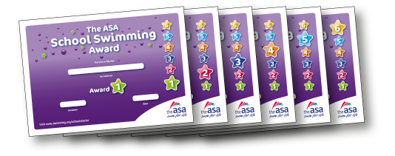

There are Awards for Aquatic Skills and Self Rescue

You will get a badge and certificate when you achieve each Award

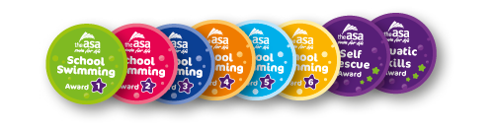

<Insert name of Champion> is the School Swimming Champion. Talk to me about anything you want to know about school swimming!

