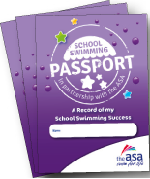

Your School Swimming Passport

- This is your personal record of your School Swimming Awards
- Fill in your details and stick in or draw your picture
- Treat it like a real Passport – a very important official document
- Take it home to show to your family but bring it back to school afterwards
- Keep this Passport safe – don’t lose it
- Keep this Passport clean – it needs to last until secondary school
- When you achieve an Award make sure you get your sticker
- Take this with you when you move schools and they will see how well you can swim!

<Insert name of Champion> is the School Swimming Champion. Talk to me about anything you want to know about school swimming!

