We’re going swimming!

- Your swimming lessons are starting on <insert date>

- Don’t forget to bring your kit: costume, goggles, locker money, towel, drink, wet bag

- The first lesson will be to find out if you are happy in the water and if you can already swim

- Next time you will be with others at the same swimming level as you

- Lessons will be fun and are something to look forward to!

- You will be able to work towards getting certificates and badges
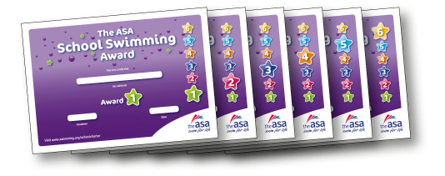

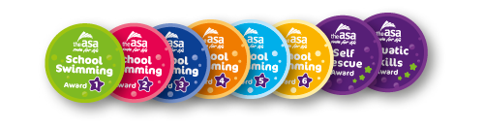

<Insert name of Champion> is the School Swimming Champion. Talk to me about anything you want to know about school swimming!

