We’re going swimming!

- Your school swimming and water safety lessons are starting on <insert date>.

- Don’t forget to bring your kit: costume, locker money, towel, drink, wet kit bag.

- You don’t need to bring goggles for school swimming.

- The first lesson will be to find out if you are happy in the water and if you can already swim.

- Next time you’ll be with others at the same swimming level as you.

- Lessons will be fun and are something you can look forward to.

- You will be able to work towards getting certificates and badges.

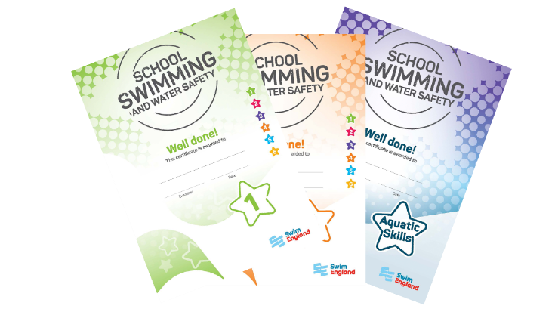

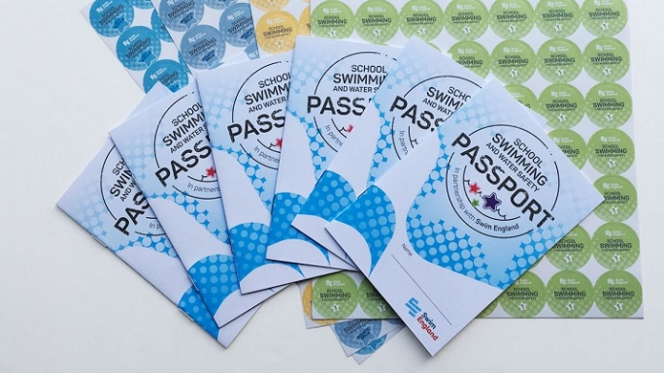

<Insert name of Champion> is the School Swimming Champion.

Talk to me about anything you want to know about school swimming and water safety.

