Artistic Swimming Figure Grade 1
The judge must be a Level 1, Level 2 or Level 3 Judge.

Name
Date

Average mark | Number below 4.5 | Result

1 | 2 | 3 | 4 | 5 | 6 | 7 | 8 | 9 | 10

Content

- Stationary back layout held for 5 seconds (BP 1).

- Front layout (BP 2) to front pike position (BP 10).

- Back layout (BP 1) to surface arch position (BP 13).

- Hanging vertical (BP 6).

- Back layout to bent knee returning to back layout (BP14b).

- Inverted split position.

- Back Layout to back pike position (BP 11).

- Back tuck somersault (Fig 310 – DD 1.1).

- Fishtail position (BP 8).

- Split position on land – Right leg and left leg. Both legs must be attempted.

General Conditions
Black costume and white hat to be worn

- All elements must be attempted and awarded a mark.

- The result will be determined by the average mark over the 10 elements.

- All elements have to contain the minimum requirements to achieve the bronze pass mark of a 5.0.

- If more than 2 elements have a score of less than 4.5 it will be an automatic fail.

- Unless otherwise stated, movements should be performed relatively stationary and in uniform motion.

- Assessments will mimic a competition and all swimmers can only attempt each element once.

- For the entries in routine grades, the water depth must be at least 1.8 meters.

- For figure grades 3-5 an appropriate depth of water should be available for vertical descents and spins.

- For dry land skills swimmers must wear fitted shorts or leggings.

- Judges are asked to highlight any areas in which the swimmers are not yet competent in the feedback box.

- No retakes will be offered unless requested by the supervising Level 3 Judge.

- All figures will be judges following the current World Aquatics judging guide.

- Any concerns about how an assessment has taken place must be brought to the supervising Level 3 Judge by a coach or team manager from the club during the assessment time.

Figure Grade 1

Focus on positions and basic positions

Element 1

Stationary back layout held for 5 seconds (BP 1).

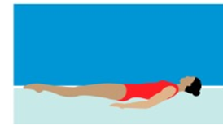

Details

Body extended with face, chest, thighs and feet at the surface. Head (ears specifically), hips, and ankles in line.

MARK

Feedback

Element 2

From a Front Layout Position (BP 2) held for 3 seconds to assume a Front Pike Position (BP 10).

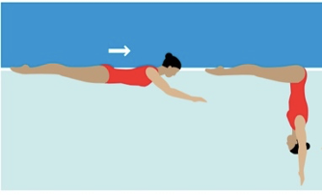

Details

From a Front Layout Position with the face in the water the trunk moves downward to assume a Front Pike Position. The buttocks, legs and feet travel along the surface of the water until the hips occupy the position of the head at the beginning of this action.

MARK

Feedback

Element 3

Back layout (BP 1) to surface arch position (BP 13) held for 3 seconds.

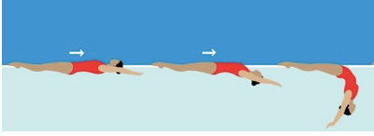

Details

From a Back Layout Position with the head leading, the head, hips and feet move along the surface of the water. With continuous movement the head leaves the surface of the water as the back is arched more to assume a Surface Arch Position with the hips occupying the position of the head at the beginning of this action. Position held for 3 seconds in split scull.

MARK

Feedback

Element 4

Hanging vertical (BP 6).

Details

Body extended, perpendicular to the surface, legs together, head downward. Head (ears specifically), hips and ankles in line. Held for 5 seconds at floating height.

MARK

Feedback

Element 5

Back layout to bent knee returning to back layout (BP 14b).

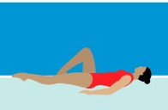

Details

Begin in a Back Layout Position. One leg remains at the surface throughout. The foot of the other leg is drawn along the inside of the extended leg to assume a Bent Knee. The toe moves along the inside of the extended leg until a Back Layout Position is assumed.

MARK

Feedback

Element 6

Inverted split position (BP 16).

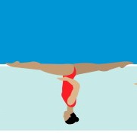

Details

Legs evenly split forward and back. The legs are parallel to the surface. Lower back arched, with hips, shoulders and head on a vertical line. 180 degree angle between the extended legs (Flat Split), with inside of each leg aligned on opposite sides of a horizontal line, regardless of the height of the hips.

MARK

Feedback

Element 7

Back Layout to back pike position (BP 11).

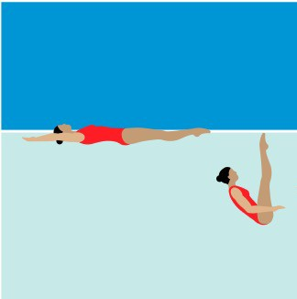

Details

From a Back Layout Position, the legs are raised to vertical as the body is submerged to a Back Pike Position with the toes just under the surface.

MARK

Feedback

Element 8

Back tuck somersault (Fig 310 – DD 1.1).

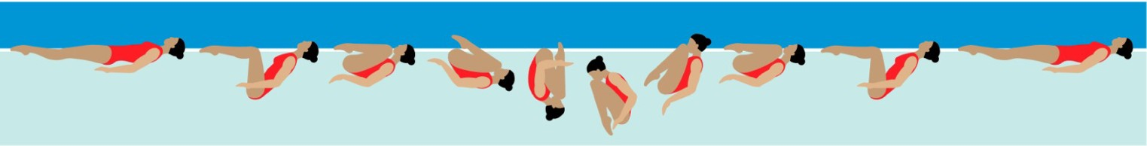

Details

From a Back Layout Position, the knees and toes are drawn along the surface to assume a Tuck Position. With continuous motion, the tuck becomes more compact as the body somersaults backward around a lateral axis for one complete revolution. A Back Layout Position is resumed.

MARK

Feedback

Element 9

Fishtail position (BP 8).

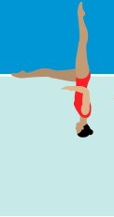

Details

Body extended in Vertical Position, with one leg extended forward to the body. The foot of the forward leg is at the surface, regardless of the height of the hips.

MARK

Feedback

Element 10

Split position on land – Right leg and left leg. Both legs must be attempted.

Details

If not flat swimmers may use blocks to support the body on both sides. For a flat and over split the crotch must be on the floor. If the swimmer is not flat then it will be measured in relation to the crotch height from the floor. All positions should be completed with full extension and body vertical or 0 will be given.

Minimum requirement is set for every split to be attempted. If swimmers do not meet the minimum requirements for the angle attempted, then they may attempt the angle below. 10cm block to be used to see the crotch distance from the floor (if not flat) and used for over splits.

MINIMUM REQUIREMENT FOR ALL ANGLES.  Legs and feet fully extended.  Body and shoulders above hips.  Hips ‘square’.  Back heel towards the ceiling.  >20cm from the floor = 0.  <20cm from the floor = 4.0.  <10cm from the floor = 5.0.  Flat split = 6.0.  10cm over split = 7.0.  20cm over split = 8.0. |  | MARK
 |  | RIGHT LEG | LEFT LEG

Feedback

