Artistic Swimming Figure Grade 4

The judge must be a Level 2 or Level 3 Judge.

|  |  |
| --- | --- |
| Name |  |
| Date |  |

|  |  |  |
| --- | --- | --- |
| Average mark | Number below 4.5 | Result |
|  |  |  |

|  |  |  |  |  |  |  |  |  |  |
| --- | --- | --- | --- | --- | --- | --- | --- | --- | --- |
| 1 | 2 | 3 | 4 | 5 | 6 | 7 | 8 | 9 | 10 |
|  |  |  |  |  |  |  |  |  |  |

Content

1. Flamingo Bent Knee, Twist spin (Fig 140g DD 2.9).
2. Cyclone, Open 180 (Fig 437 DD 2.6).
3. Barracuda Airbourne split spin up 180 (Fig 308h DD 2.9).
4. Swordfish straight leg Ariana rotation (Fig 407 DD 2.6).
5. Whip Continuous Spin 720 (Fig 356f. DD 3.0).
6. Saturn (Fig 441 DD 2.5).
7. Venus (Fig 352. DD 3.0).
8. Albatross Spin up 360 (Fig 240i. DD 2.5).
9. Rio Straight Leg (Fig 144 DD3.1).
10. Walkover Back Closing 360 (Fig 421 DD 2.4).
11. Ipanema Spinning 180 (Fig 440d DD 3.1).
12. Kip Combined Spin (Fig 311j DD 2.4).
13. Split position on land – right leg and left leg. Both legs must be attempted.

General Conditions

# Black costume and white hat to be worn

1. All elements must be attempted and awarded a mark.
2. The result will be determined by the average mark over the 10 elements.
3. All elements have to contain the minimum requirements to achieve the bronze pass mark of a 5.0.
4. If more than 2 elements have a score of less than 4.5 it will be an automatic fail.
5. Unless otherwise stated, movements should be performed relatively stationary and in uniform motion.
6. Assessments will mimic a competition and all swimmers can only attempt each element once.
7. For the entries in routine grades, the water depth must be at least 1.8 meters.
8. For figure grades 3-5 an appropriate depth of water should be available for vertical descents and spins.
9. For dry land skills swimmers must wear fitted shorts or leggings.
10. Judges are asked to highlight any areas in which the swimmers are not yet competent in the feedback box.
11. No retakes will be offered unless requested by the supervising Level 3 Judge.
12. All figures will be judges following the current World Aquatics judging guide.
13. Any concerns about how an assessment has taken place must be brought to the supervising Level 3 Judge by a coach or team manager from the club during the assessment time.

Figure Grade 4

# Focus on 13-15 figures

# Element 1

Flamingo Bent Knee, Twist spin (Fig 140g DD 2.9).

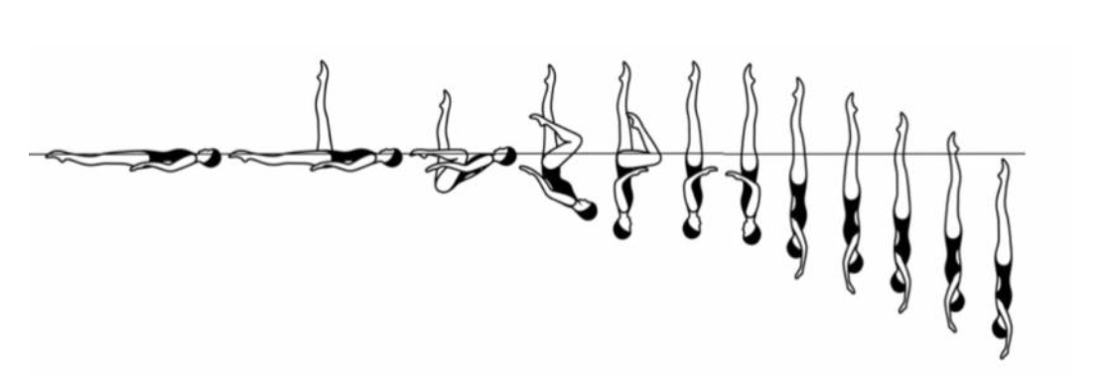

# Details

A Ballet Leg is assumed. The shin of the horizontal leg is drawn along the surface of the water to assume a **Surface Flamingo Position**. With the ballet leg maintaining its vertical position the hips are lifted as the trunk unrolls while the bent leg moves to a **Bent Knee Vertical Position**. The bent leg is extended to a Vertical Position. A **Twist Spin** is executed.

|  |  |  |
| --- | --- | --- |
|  |  | **MARK** |

|  |
| --- |
| Feedback |
|  |

# Element 2

Cyclone, Open 180 (Fig 437 DD 2.6).

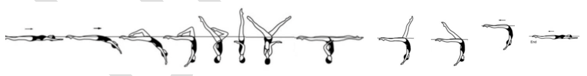

# Details

From a **Back Layout Position** a **Bent Knee Surface Arch Position** is assumed. The legs are simultaneously lifted to a **Vertical Position** as a **Twirl** is executed. Continuing in the same direction the legs are opened symmetrically to a Split Position as a 180 degrees rotation is executed. A **Walkout Front** is executed.

|  |  |  |
| --- | --- | --- |
|  |  | **MARK** |

|  |
| --- |
| Feedback |
|  |

# Element 3

Barracuda Airbourne split spin up 180 (Fig 308h DD 2.9).

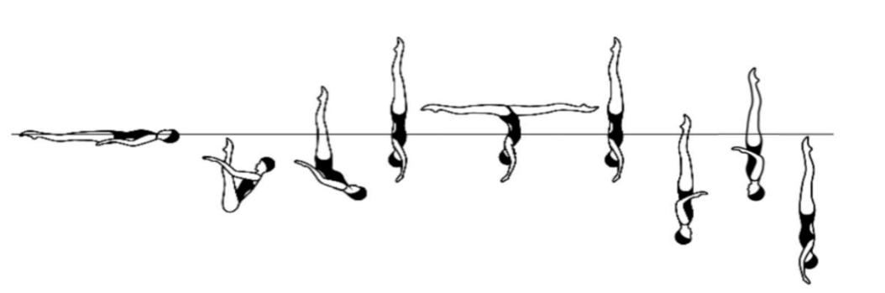

# Details

From a **Back Layout Position** the legs are raised to a vertical as the body is submerged to a **Back Pike Position** with the toes just under the surface of the water. All remaining movements are performed rapidly. A **Rocket Split** is executed. A **Vertical Descent** is executed and is completed as the ankles reach the surface of the water. A Spin Up 180 degrees is executed. A **Vertical Descent** is executed.

|  |  |  |
| --- | --- | --- |
|  |  | **MARK** |

|  |
| --- |
| Feedback |
|  |

# Element 4

Swordfish straight leg Ariana rotation (Fig 407 DD 2.6).

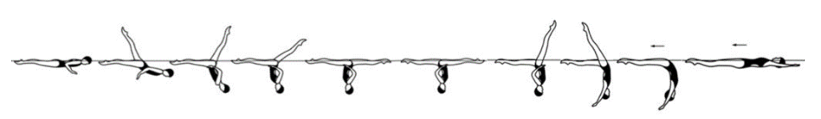

# Details

From a **Front Layout Position** the back arches as one leg is lifted in a 180 degrees arc over the surface of the water to a **Split Position**. Maintaining the relative position of the legs to the surface of the water an **Ariana Rotation** is performed. A **Walkout Front** is executed.

|  |  |  |
| --- | --- | --- |
|  |  | **MARK** |

|  |
| --- |
| Feedback |
|  |

# Element 5

Whip Continuous Spin 720 (Fig 356f. DD 3.0).

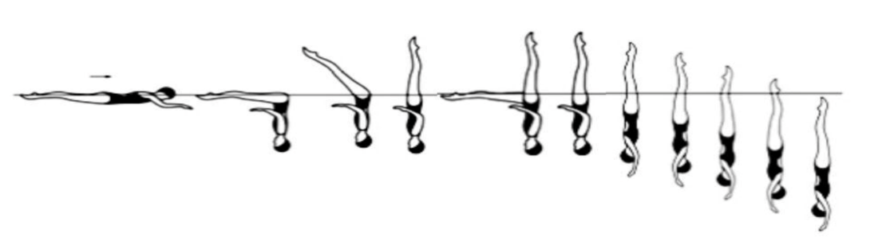

# Details

From a **Front Layout Position** a **Front Pike Position** is assumed. The legs are lifted to a **Vertical Position**. All remaining movements are performed rapidly. One leg is lowered to a Fishtail Position and without a pause is lifted to a **Vertical Position**. Without a pause a **Continuous Spin 720 degrees** is executed.

|  |  |  |
| --- | --- | --- |
|  |  | **MARK** |

|  |
| --- |
| Feedback |
|  |

# Element 6

Saturn (Fig 441 DD 2.5).

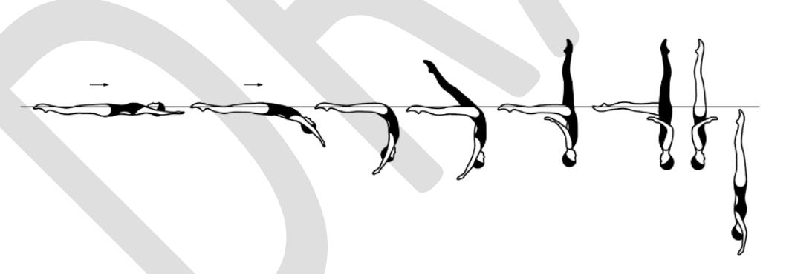

# Details

From a **Back Layout Position** a **Surface Arch Position** is assumed. One leg is lifted to assume a **Knight Position**. Maintaining the vertical alignment the body rotates 180 degrees to assume a **Fishtail Position**. Continuing in the same direction a Twirl is executed as the horizontal leg is lifted to a **Vertical Position**. A **Vertical Descent** is executed.

|  |  |  |
| --- | --- | --- |
|  |  | **MARK** |

|  |
| --- |
| Feedback |
|  |

# Element 7

Venus (Fig 352. DD 3.0).

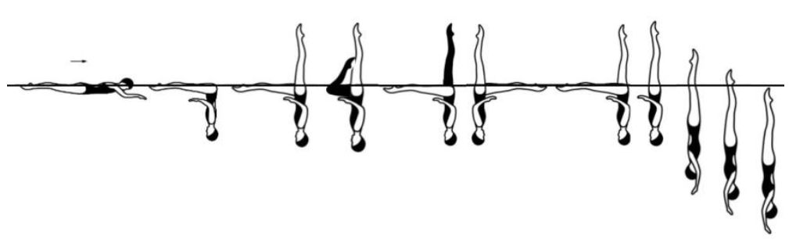

# Details

From a **Front Layout Position** a **Front Pike Position** is assumed. All remaining movements are performed rapidly. One leg is lifted to a **Fishtail Position**. The horizontal leg is bent to assume a **Bent Knee Vertical Position**. The bent leg is extended to vertical as the vertical leg is lowered to become the horizontal leg in **Fishtail Position**. A rotation of 360 degrees is executed in the Fishtail Position. The horizontal leg is lifted to a **Vertical Position**. A **360 Degree Spin** is executed.

|  |  |  |
| --- | --- | --- |
|  |  | **MARK** |

|  |
| --- |
| Feedback |
|  |

# Element 8

Albatross Spin up 360 (Fig 240i. DD 2.5).

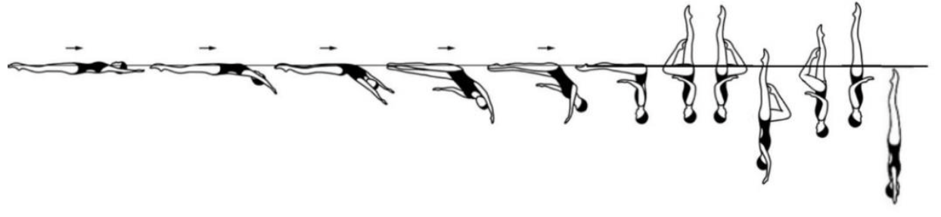

# Details

From a **Back Layout Position** with the head leading, the head, hips and feet move along the surface of the water. The hips, legs and feet continue to move along the surface of the water as the body rolls onto the face and a **Front Pike Position** is assumed with the hips occupying the position of the head at the beginning of this action. The legs are lifted simultaneously to a **Bent Knee Vertical Position**. A **Half Twist** is executed. Maintaining a **Bent Knee Vertical Position**, a Vertical Descent is executed until the ankle of the extended leg reaches the surface of the water. A **Spin Up 360 Degrees** is executed as the bent leg is extended to **Vertical Position**. A **Vertical Descent** is executed.

|  |  |  |
| --- | --- | --- |
|  |  | **MARK** |

|  |
| --- |
| Feedback |
|  |

# Element 9

Rio Straight Leg (Fig 144 DD3.1).

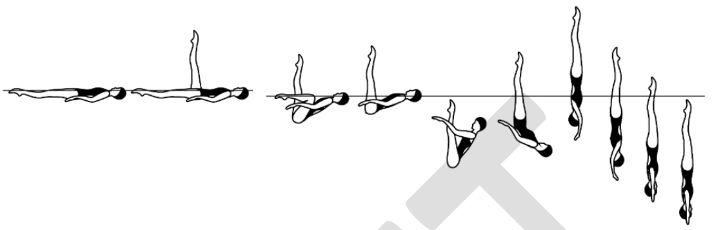

# Details

A **Straight Ballet Leg** is assumed. The knee, shin and toes of the horizontal leg are drawn along the surface of the water to assume a **Surface Flamingo Position**. The bent leg is straightened to a **Surface Ballet Leg Double Position**. The body submerges vertically to a **Back Pike Position** with the toes just under the surface of the water. A Thrust is executed to a **Vertical Position**. A **Spinning 360 Degrees** is executed at the same tempo as the **Thrust**.

|  |  |  |
| --- | --- | --- |
|  |  | **MARK** |

|  |
| --- |
| Feedback |
|  |

# Element 10

Walkover Back Closing 360 (Fig 421 DD 2.4).

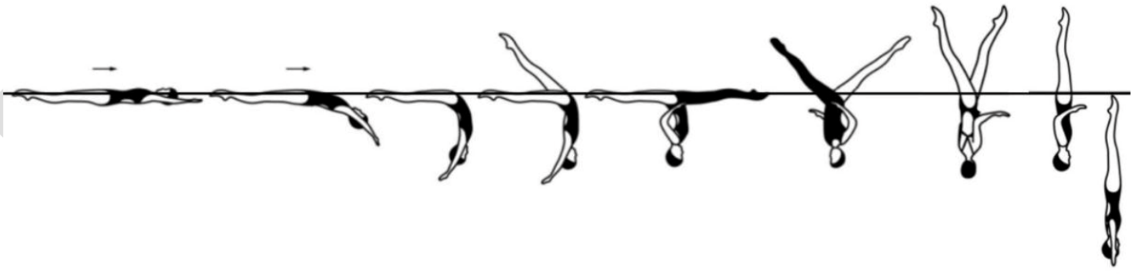

# Details

From a **Back Layout Position** a **Surface Arch Position** is assumed. One leg is lifted in a 180 degree arc over the surface of the water to a **Split Positio**n. With continuous motion a rotation of 360 degrees is executed as the legs are symmetrically lifted and closed to a **Vertical Position**. A **Vertical Descent** is executed.

|  |  |  |
| --- | --- | --- |
|  |  | **MARK** |

|  |
| --- |
| Feedback |
|  |

# Element 11

Ipanema Spinning 180 (Fig 440d DD 3.1). 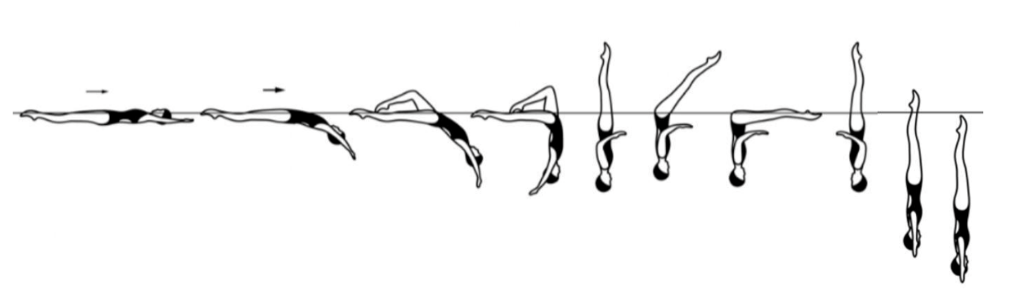

# Details

From a **Back Layout Position** a **Bent Knee Surface Arch Position** is assumed. The horizontal leg is lifted to vertical as the bent leg is straightened to assume a **Vertical Position**. The legs are lowered to a **Front Pike Position**. A rapid 180 degree rotation is executed as the legs are lifted to a **Vertical Position**. Continuing in the same direction a rapid 180 degree spin is executed.

|  |  |  |
| --- | --- | --- |
|  |  | **MARK** |

|  |
| --- |
| Feedback |
|  |

# Element 12

Kip Combined Spin (Fig 311j DD 2.4). 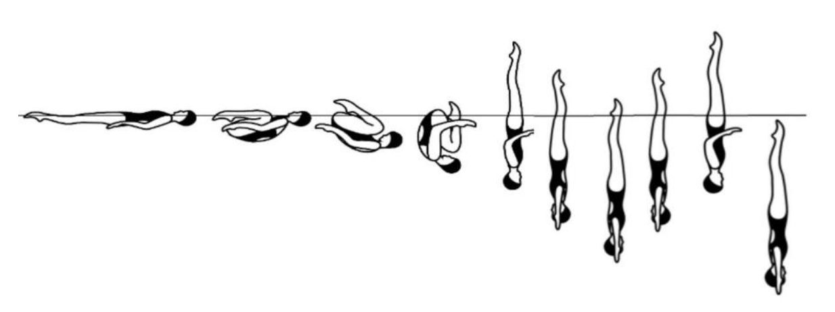

# Details

From a **Back Layout Position** the knees, shins and toes are drawn along the surface of the water to assume a **Tuck Position**. With continuous motion the tuck becomes more compact and a partial **Somersault Back Tuck** is executed until the shins are perpendicular to the surface of the water. The trunk unrolls as the legs are straightened to assume a **Vertical Position** midway between the former vertical line through the hips and the former vertical line through the head and the shins. A rapid **Combined Spin** (360 degree + 360 degree) is executed followed by a rapid **Vertical Descent**.

|  |  |  |
| --- | --- | --- |
|  |  | **MARK** |

|  |
| --- |
| Feedback |
|  |

# Element 13

Split position on land – Right leg and left leg. Both legs must be attempted.

# Details

If not flat swimmers may use blocks to support the body on both sides. For a flat and over split the crotch must be on the floor. If the swimmer is not flat then it will be measured in relation to the crotch height from the floor. All positions should be completed with full extension and body vertical or 0 will be given.

Minimum requirement is set for every split to be attempted. If swimmers do not meet the minimum requirements for the angle attempted, then they may attempt the angle below. 10cm block to be used to see the crotch distance from the floor (if not flat) and used for over splits.

|  |  |  |  |
| --- | --- | --- | --- |
| **MINIMUM REQUIREMENT FOR ALL ANGLES.**  Legs and feet fully extended.  Body and shoulders above hips.  Hips ‘square’.  Back heel towards the ceiling.  >20cm from the floor = 0.  <20cm from the floor = 4.0.  <10cm from the floor = 5.0.  Flat split = 6.0.  10cm over split = 7.0.  20cm over split = 8.0. |  | **MARK** | |
|  | **RIGHT LEG** | **LEFT LEG** |

|  |
| --- |
| Feedback |
|  |