Artistic Swimming Figure Grade 5
The judge must be a Level 2 or Level 3 Judge.

Name
Date

Average mark | Number below 4.5 | Result

1 | 2 | 3 | 4 | 5 | 6 | 7 | 8 | 9 | 10

Content

- Team Element 1B – Flying fish hybrid DD 2.3.

- Team element 2B – vertical - half twist to bent knee – half twist to vertical – split – walk out DD 2.3.

- Team Element 3B – Two Fouette Rotations – vertical spinning 360 DD 2.3.

- Team element 4 – Butterfly hybrid DD 2.9.

- Team element 5B – Rocket Split Bent knee Hybrid DD 2.1.

- Duet Element 1B – Walk over back closing 180 – Continuous spin DD 2.5.

- Duet Element 3B – Flamingo half twist hybrid DD 2.6.

- Duet Element 4B – Fishtail – Knight – Continuous spin 720 DD 2.7.

- Solo Element 2B – Combined spin 720 – continuous spin 1080 DD 2.7.

- Split position on land – right leg and left leg. Both legs must be attempted.

General Conditions

Black costume and white hat to be worn

- All elements must be attempted and awarded a mark.

- The result will be determined by the average mark over the 10 elements.

- All elements have to contain the minimum requirements to achieve the bronze pass mark of a 5.0.

- If more than 2 elements have a score of less than 4.5 it will be an automatic fail.

- Unless otherwise stated, movements should be performed relatively stationary and in uniform motion.

- Assessments will mimic a competition and all swimmers can only attempt each element once.

- For the entries in routine grades, the water depth must be at least 1.8 meters.

- For figure grades 3-5 an appropriate depth of water should be available for vertical descents and spins.

- For dry land skills swimmers must wear fitted shorts or leggings.

- Judges are asked to highlight any areas in which the swimmers are not yet competent in the feedback box.

- No retakes will be offered unless requested by the supervising Level 3 Judge.

- All figures will be judges following the current World Aquatics judging guide.

- Any concerns about how an assessment has taken place must be brought to the supervising Level 3 Judge by a coach or team manager from the club during the assessment time.

Figure Grade 5

Focus on FINA B Elements

Element 1

Team Element 1B – Flying fish hybrid DD 2.3.

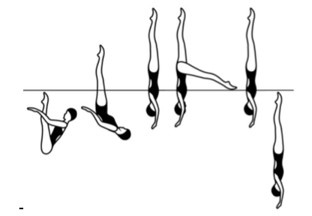

Details

From a Submerged Back Pike Position with the legs perpendicular to the surface, a Thrust is executed to a Vertical Position and with no loss of height one leg is rapidly lowered to an airborne Fishtail Position. Without a pause the horizontal leg is rapidly lifted to a Vertical Position followed by a Vertical Descent (DD 2.3).

MARK

Feedback

Element 2

Team element 2B – vertical - half twist to bent knee – half twist to vertical – split – walk out DD 2.3.

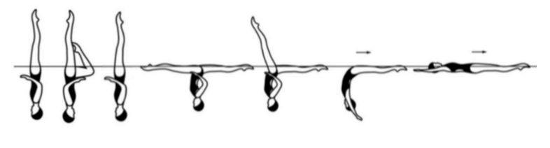

Details

Starting in a Vertical Position, a Half Twist is executed as one leg is lowered to a Bent Knee Vertical Position. Continuing in the same direction another Half Twist is executed, as the bent knee is extended to a Vertical Position. The legs are symmetrically lowered to a Split Position. A Walkout Front is executed.

MARK

Feedback

Element 3

Team Element 3B – Two Fouette Rotations – vertical spinning 360 DD 2.3.
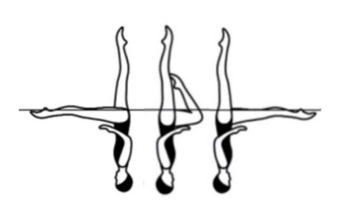
Fouetté Rotation - New movement

From a Fishtail Position, with the horizontal leg leading toward the vertical leg, a rapid 180 degrees rotation is executed as the front leg bends to assume a Bent Knee Vertical Position. The bent leg rapidly extends to a Fishtail Position.

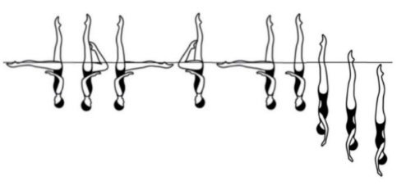

Details

From a Fishtail Position, two Fouetté rotations (180 degrees + 180 degrees) are executed. The horizontal leg is rapidly lifted to a Vertical Position. Continuing in the same direction, a rapid Spinning 360 Degrees (one rotation) is executed.

MARK

Feedback

Element 4

Team element 4 – Butterfly hybrid DD 2.9.

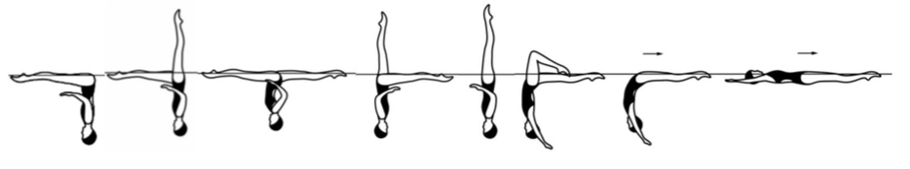

Details

The Butterfly Hybrid is to be performed rapidly. From a Front Pike Position, one leg is lifted to a Fishtail Position. The horizontal leg is lifted through an arc of 180 degrees as the vertical leg is lowered to assume a Split Position. Without a pause a hip rotation of 180 degrees is executed as the front leg is raised to assume a Fishtail Position. Continuing in the same direction a 180 degrees rotation is executed as the horizontal leg is lifted to a Vertical Position. The legs are lowered simultaneously to a Bent Knee Surface Arch Position. Note: The Bent Knee Surface Arch Position can be assumed by using either leg). The bent knee is straightened to a Surface Arch Position and with continuous motion an Arch to Back Layout Finish Action is executed.

MARK

Feedback

Element 5

Team element 5B – Rocket Split Bent knee Hybrid DD 2.1.

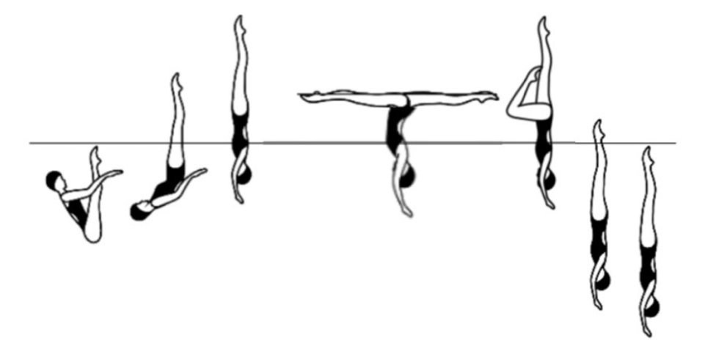

Details

From a Submerged Back Pike Position with the legs perpendicular to the surface, a Thrust is executed to a Vertical Position. Maintaining maximum height, the legs are split rapidly to assume an Airborne Split Position followed by the front leg rapidly bending and the back leg rapidly lifting to a vertical to assume an airborne Bent Knee Vertical Position. A Vertical Descent is executed as the bent knee is extended to join the vertical leg completed as the ankles reach the surface of the water followed by a Vertical Descent.

MARK

Feedback

Element 6

Duet Element 1B – Walk over back closing 180 – Continuous spin DD 2.5.
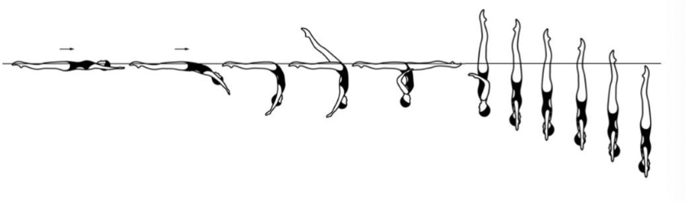

Details

From a Back Layout Position a Surface Arch Position is assumed. One leg is lifted in a 180 degrees arc over the surface to a Split Position. A rotation of 180 degrees is executed, as the legs symmetrically close to a Vertical Position. Continuing in the same direction a Continuous Spin of 720 Degrees (two rotations) is executed.

MARK

Feedback

Element 7

Duet Element 3B – Flamingo half twist hybrid DD 2.6.

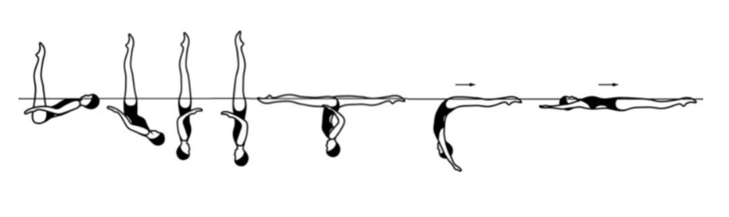

Details

From a Surface Ballet Leg Double Position, maintaining the vertical position of the legs, the hips are lifted as the trunk is unrolled to a Vertical Position. A Half Twist is executed. Without a pause the legs open symmetrically to a Split Position. A Walkout Front is executed.

MARK

Feedback

Element 8

Duet Element 4B – Fishtail – Knight – Continuous spin 720 DD 2.7.

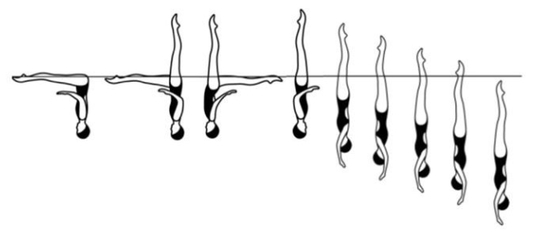

Details

From a Front Pike Position one leg is lifted to a Fishtail Position. The horizontal leg is rapidly lifted through an arc of 180 degrees to assume a Knight Position. A rapid Half Twist is executed as the horizontal leg is lifted to a Vertical Position. Continuing in the same direction a Continuous Spin 720 Degrees (two rotations) is executed.

MARK

Feedback

Element 9

Solo Element 2B – Combined spin 720 – continuous spin 1080 DD 2.7.

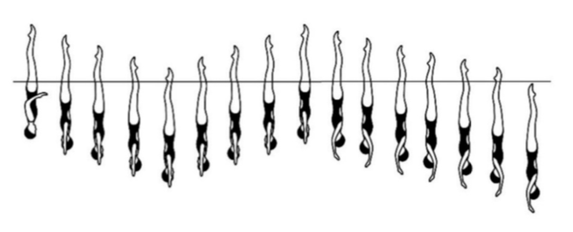

Details

From a Vertical Position a Combined Spin of 720 Degrees is executed (two rotations + two rotations). Continuing in the same direction and without a pause a Continuous Spin 1,080 Degrees (three rotations) is executed.

MARK

Feedback

Element 10

Split position on land – Right leg and left leg. Both legs must be attempted

Details

If not flat swimmers may use blocks to support the body on both sides. For a flat and over split the crotch must be on the floor. If the swimmer is not flat then it will be measured in relation to the crotch height from the floor. All positions should be completed with full extension and body vertical or 0 will be given. Minimum requirement is set for every split to be attempted.

If swimmers do not meet the minimum requirements for the angle attempted, then they may attempt the angle below. 10cm block to be used to see the crotch distance from the floor (if not flat) and used for over splits.

MINIMUM REQUIREMENT FOR ALL ANGLES.  Legs and feet fully extended.  Body and shoulders above hips.  Hips ‘square’.  Back heel towards the ceiling.  > 20cm from the floor = 0.  <20cm from the floor = 4.0.  <10cm from the floor = 5.0.  Flat split = 6.0.  10cm over split = 7.0.  20cm over split = 8.0. |  | MARK
 |  | RIGHT LEG | LEFT LEG

Feedback

