National Para-Swimming Pathway Engagement Day (on-line via Zoom)
Sunday 13th December 2020

Athletes: 9:45am – 1:00pm (Coaches are welcome to observe)
Coaches and Club Administrators 2:00pm – 4:30pm

Join the England Para - Swimming Talent Team for a FREE, fun day of workshops and activities, designed to help athletes, coaches and parents / guardians gain valuable information about the development of Para-athletes.

Who is this day for?
- Athletes who attend Regional Para-Swimming Training in their region
- All classified athletes and those on the classification waiting list who would like to develop their swimming further
- Category 2 members who have an eligible Para-Swimming impairment or hearing impairment and would like to learn more about Para-Swimming, or development / competitive opportunities
- Coaches who would like to gain a greater knowledge of Para-Swimming and the support available to them and to athletes.
- Club Administrators, exploring ways of developing Para-Swimming within their club environment.
*This day is not open to athletes on a National / British Para-Swimming Talent Programme*.
**All athletes under the age of 16 should be accompanied by an adult throughout.

Meet the team delivering on the day:
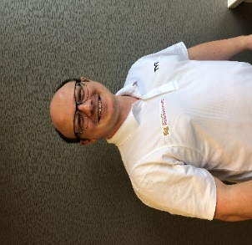
Martin Lees – England Para-Swimming Development Manager
- Martin can give you an update of opportunities available to clubs to develop their Para-Swimming offering

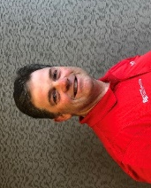
Carl Cooper – England Para-Swimming Talent Coach
- Carl leads on athlete development and can give athletes hints and tips to developing their training and performance as well as an insight into the common traits of successful Para-Swimmers

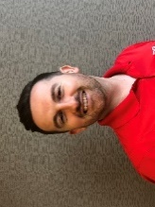
Tom McManus – England Para-Swimming Talent Coach
- Tom leads on coach development and can give coaches hints and tips to developing their programme, whilst exploring some adaptations used with Para-Swimmers

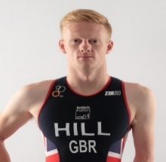
Dave Hill - England Para-Swimming Foundation S&C lead
- Two time Paralympian in Swimming & Triathlon,
- World & European Medallist, British Champion
- Team GB's Youngest Athlete at the Athens 2004 Paralympics.
- Top 10 Finisher in the Rio-de-Janerio 2016 Paralympics
.
Dave now works as an Athlete Mentor, is a qualified Swimming Coach and Personal Trainer and is passionate to pass on his knowledge to the next generation. David leads on Strength & Conditioning for the National Para-Swimming Foundation programme and Regional Training, providing a wealth of experience to help develop athletes at all levels.

Timeline of the day

AM – Session Athletes (coaches are welcome and can observe)

Time | Activity Workshop | Notes
09:30 – 09:45 | Log-In | Please have cameras switched on when joining the meeting and names match the application
09:45 – 10:00 | Welcome
10:00 – 11:00 | RMAP - workout | Athletes require appropriate clothing and a safe / clear space for physical activity. It is advised to have a water bottle available for hydration throughout.
11:00 – 11:15 | Break
11:15 – 12:00 | Workshop 1 ‘Introducing the Pillars of Development’ | Athletes may wish to make notes during workshops but slides will be available afterwards.
12:00 – 12:40 | Workshop 2  ‘The importance of the process mind-set’
12:40 – 13:00 | Q&A’s Summary Depart

PM Session Coaches / Club administrators

Time | Activity Workshop | Who | Notes
13:45 – 14:00 | Log-In | Coaches / Administrators | Please have cameras switched on when joining the meeting and names match the application
14:00 – 14:15 | Welcome | All
14:15 – 15:00 | Workshop 1 – Coaching development / Pathways | Coaches | Breakout Room 1
14:15 – 15:00 | Workshop 2 – Club opportunities and the wider development of Para-Swimming | Administrators | Breakout Room 2
15:00 – 15:15 | Break
15:15 – 16:00 | Workshop 3 – The Holistic development of a Para-Swimmer and the Pillars of Development | All | Attendees may wish to make notes during workshops but slides will be available afterwards.
16:00 – 16:30 | Q&A – Summary - Depart | All

How to book onto the day.
Please contact your regional contact to let them know of your intention to attend. Please give them the following information to ensure you are placed in the most appropriate workshop and that further breakout rooms can be organised if needed, based on numbers.

- Name
- Club
- Classification (Athletes)
- Email address for communication and for sending information afterwards
- Contact Telephone number
- Please indicate if you are an Athlete / Coach / Administrator

In order to receive the logging-on details, please return to James Warrener- James.warrener@londonswimming.org :
We look forward to seeing you on the day.
The Para-Swimming Talent Team

