How to activate your account

Welcome to the Online Membership System (OMS), the web address is: www.swimmingmembers.org

If this is the first time you’ve visited OMS, you will need to activate your account. Follow the instructions below, you will need to have your membership number, the main email address held by Swim England & your surname to hand.

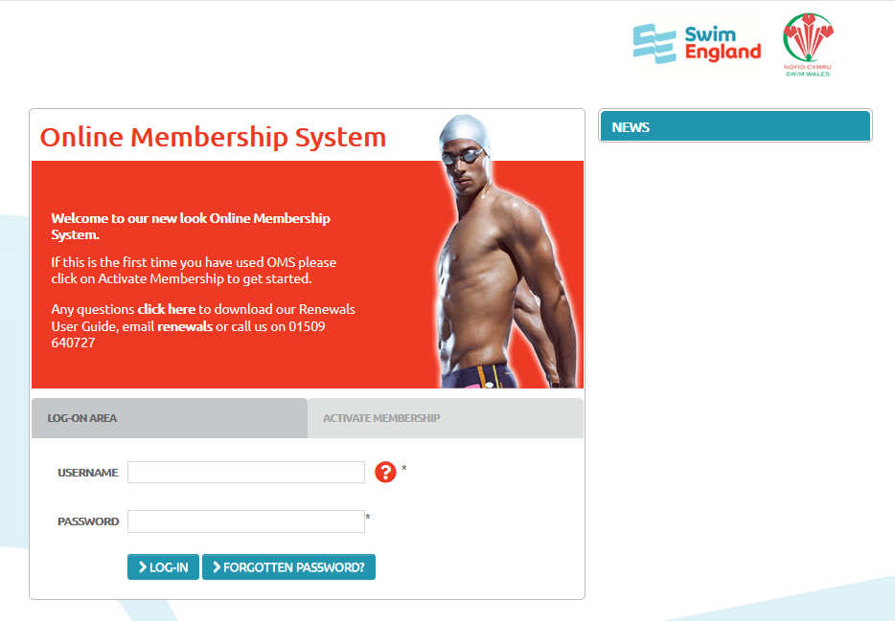

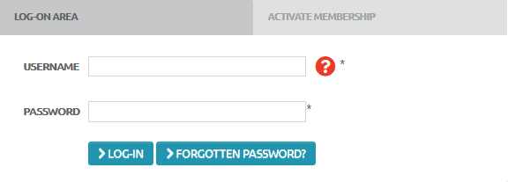
On the main Welcome Page, there is a “Log-On Area” and there is an “Activate Membership” area.

To activate your account click on the grey “Activate Membership” tab.

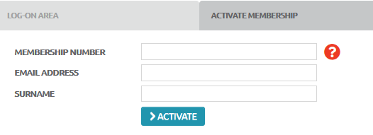
Enter your membership number, email address and surname.

Type your details into all three fields and then click on the blue Activate button.

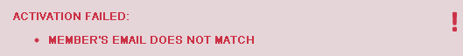
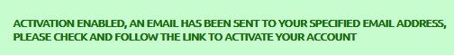
Activation Enabled

If the activation was successful a message will appear stating that an email has been sent to your email address.

Please open the email from Swim England OMS which will be titled: “Swim England Online Membership System - Account activation enabled” and click on the link contained within it.

Please also check your spam & junk email folders as the email may have arrived in one of these rather than your inbox

Please note – this message is only valid for 24 hours, after that time the link will expire and you will need to start the activation process again.
Activation Failed

If the details you have entered cannot be matched to the information held on our database you will see the following message “Activation Failed” and then a description of the information that has not matched. Please check the information and re-enter if necessary – you may need to refresh your internet browser page before clicking the Activate button again.

If the system still does not recognise your information please contact us on 01509 640727 or renewals@swimming.org

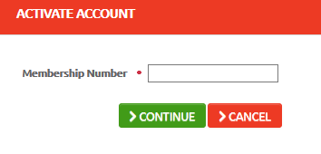
Once you’ve clicked on the link within the email, the OMS website opens to display the Activate Account page, please enter your membership number here and then click on the green Continue button.

The top half of the Activate Account page now displays your details; these details are held in our central database and can be amended once logged into the OMS. If this is not you, press cancel.

The bottom half of the Activate Account page requires a password to be entered and then confirmed. This password needs to be at least 8 Characters contain a mix of letters and numbers. At least one letter must be uppercase. Symbols and spaces are not permitted.
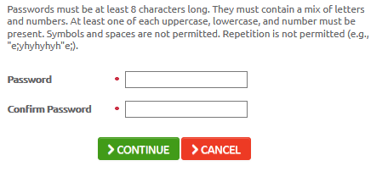
When you have confirmed your password please click on the green “Continue” button, you will now be logged in to your Membership Page.

Congratulations – you have successfully activated your account and are now logged into the OMS, please keep a note of the password you have entered and your membership number as you will need them in the future to log in.

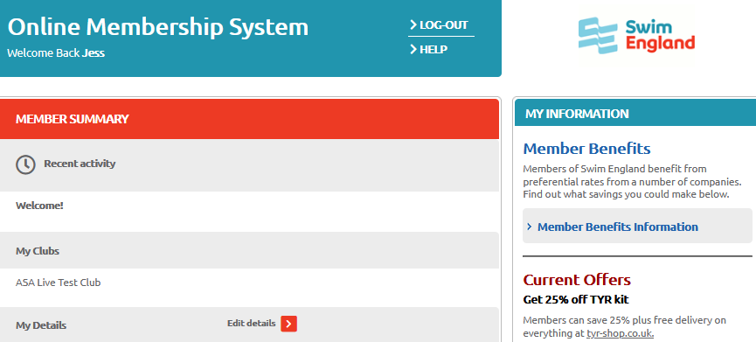

Updating Your Information
The Member Summary page will list your clubs and contact information. If your contact details are incorrect you can edit these by clicking “Edit details”. Form this page you can also enter what activity you take part in with your clubs including your discipline. If you are under 13 years a parent email must be included.

